The Department of English 2021-22
“Cultural Trauma, Biopolitics and Precarious Lives in the 21st Century” WEBINAR REPORT

Title of the webinar: “Cultural Trauma, Biopolitics and Precarious Lives in the 21st Century”.

Theme: 21st century lives, commentators argue, are enmeshed in bio-economies and biopolitics. The trade, traffic and legislation of tissues, organs and biomatter, from blood to cells, is also, however, a component of a larger precarity that troubles us today. This talk focused on a specific form of cultural trauma connected with the biopolitical: posthuman trauma. It moved from the trauma of corporeal precarity to the trauma of judicialized life and finally species trauma.

Objectives:
To critically examine the concept of cultural trauma and its relevance to contemporary societies in the 21st century.

To explore the role of biopolitics in shaping and managing precarious lives in the context of cultural trauma.

To analyze the ways in which cultural trauma and biopolitics intersect and shape social, cultural, and political landscapes in the 21st century.

To investigate the impact of cultural trauma and biopolitics on individuals and communities, with a focus on issues such as identity, memory, and subjectivity.

To identify and explore alternative approaches and strategies that can be used to address the challenges posed by cultural trauma, biopolitics, and precarious lives in the 21st century.

Day, Date and Time: 7th August 2021 from 5:00 pm – 6:30 pm Location: (Online) M S Teams

Attended participants number: 244

Details of Webinar: The Department of English of SIES College of Arts, Science and Commerce, Autonomous, Sion (W) conducted its foremost event, a National Webinar entitled "Cultural Trauma, Biopolitics and Precarious Lives in the 21st Century" by Dr. Pramod K. Nayar on 7th August, 2021. The webinar was held on Microsoft Team and was live streamed on YouTube as well. The event was presided over by Dr. Lakshmi Muthukumar, the HOD of the English Association. Dr. Muthukumar requested Dr. Uma Shankar, Principal of SIES College to say a few words about the same. Next, she welcomed and introduced the speaker of the day, Dr. Pramod K. Nayar. The speaker focused and spoke about a specific form of cultural trauma connected with biopolitics i.e., Posthuman Trauma. Mr. Nayar precisely explained the meanings of terms such as Cultural Trauma and Citizenship, Biopolitics, Eco Precarity, and Precarious Corporeality with the aid of a PowerPoint Presentation. He impeccably elaborated his points by giving real-life and contemporary examples of books and movies. The event started at 4:50 p.m. and concluded at 6:30 p.m. in the evening and a total number of 244+ attendees participated in the webinar and 718 people viewed the webinar on YouTube. Students, Professors and Research Scholars pan-India as well as across India actively participated in the event. The second part of the event was a Q&A session with the speaker. Dr. Seema C, moderated the questions posed by the research scholars and the students in the comment section of YouTube Live. Vidya Hariharan, voiced a vote of thanks applauding everyone who contributed in making the National Webinar possible. A feedback link was posted in the comment section for the attendees in order to be able to receive their certificates.

Name of Resource Person: Dr. Pramod K. Nayar

Outcomes:
Increased awareness and understanding of the complex relationship between cultural trauma, biopolitics, and precarious lives in the 21st century.

Enhanced knowledge of the latest research, theories, and practices in the field of cultural trauma and biopolitics.

A greater appreciation of the impact of cultural trauma and biopolitics on individuals and communities, as well as the social, cultural, and political landscapes in which they are embedded.

Identification of new research questions, ideas, and areas of inquiry that can inform future scholarship and policy.

Improved collaboration and networking among scholars, researchers, and practitioners working in related fields.

Increased public engagement and awareness of the importance of addressing issues related to cultural trauma, biopolitics, and precarious lives.
Annexures:

- Photographs:

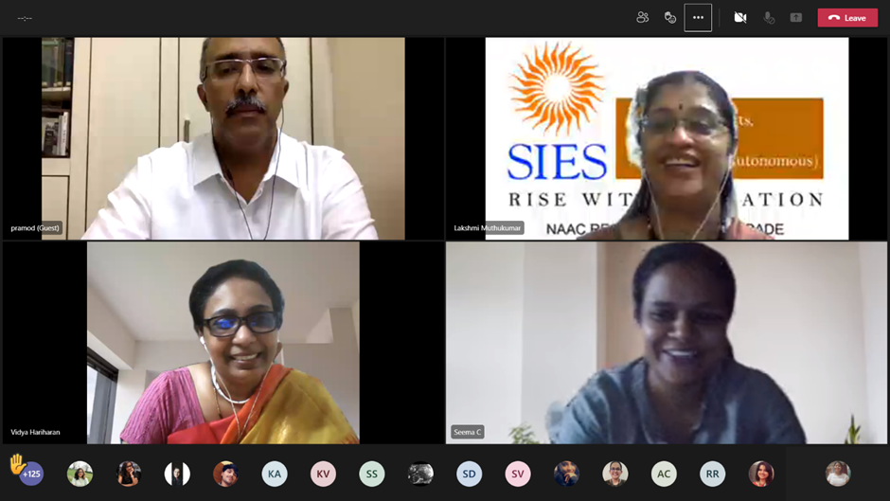

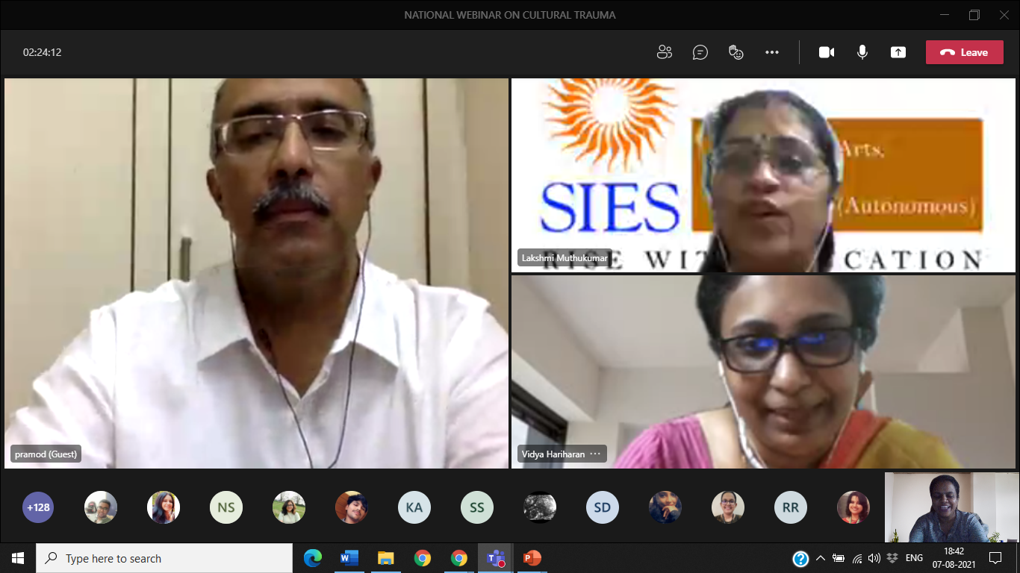

Dr. Pramod K. Nayar with participants during the webinar on “Cultural Trauma, Biopolitics and Precarious Lives in the 21st Century.” Held on 7th August 2021 from 5pm – 6:30pm on M S Teams.
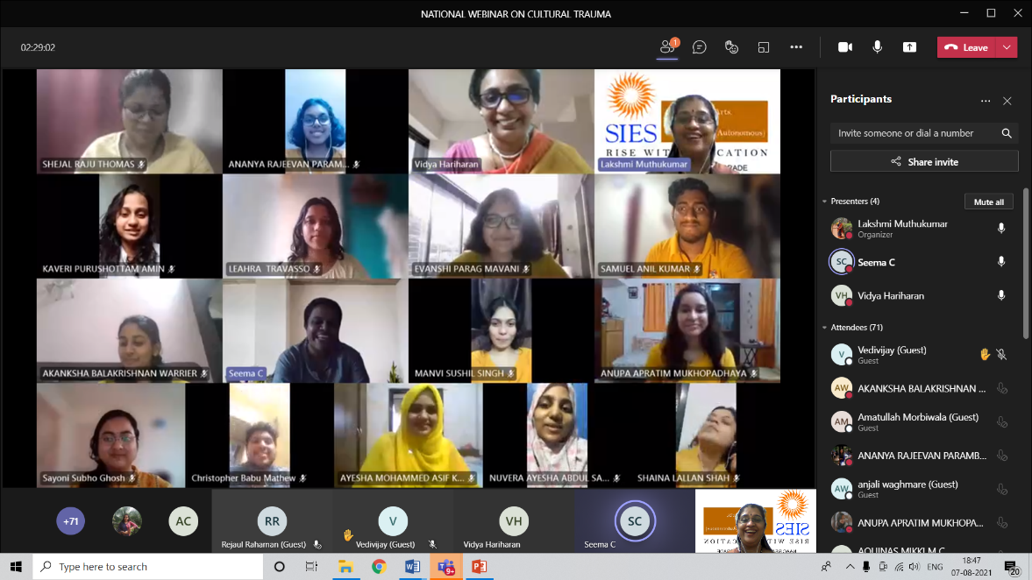

The participants during the webinar webinar on “Cultural Trauma, Biopolitics and Precarious Lives in the 21st Century.” Held on 7th August 2021 from 5pm – 6:30pm on M S Teams.

II. List of attendees:

Attendance report of the National Webinar Cultural Trauma, Biopolitics and Precarious Lives in the 21st Century”
Full Name | User Action | Timestamp
Lakshmi Muthukumar | Joined | 8/7/2021, 4:35:18 PM
Maya Nair | Joined before | 8/7/2021, 4:35:18 PM
nishahimanshi | Joined before | 8/7/2021, 4:35:18 PM
Geetha P | Joined before | 8/7/2021, 4:35:18 PM
AQUINAS MIKKI M C | Joined | 8/7/2021, 4:35:26 PM
Maria Noronha (Guest) | Joined | 8/7/2021, 4:39:44 PM
DEANNE MARIA DSILVA | Left | 8/7/2021, 4:39:52 PM
Mahalaxmi Samuthiram Nadar | Joined | 8/7/2021, 4:40:27 PM
Vedang Mukund Deshpande | Joined | 8/7/2021, 4:40:32 PM
PRADEEP KARANSINGH JOGI | Joined | 8/7/2021, 4:40:39 PM
ZAINAB RASHID SAYYED | Joined | 8/7/2021, 4:40:45 PM
GURLEEN KAUR DHARMINDER SINGH KAPOOR | Joined | 8/7/2021, 4:40:46 PM
SAMUEL ANIL KUMAR | Joined | 8/7/2021, 4:40:56 PM
SURAJ SIVARAMAKRISHNAN IYER | Joined | 8/7/2021, 4:40:59 PM
SANIKA RAJESH DESHPANDE | Joined | 8/7/2021, 4:41:00 PM
Krysha Sanjeev Sharma | Joined | 8/7/2021, 4:41:02 PM
DEESA CHETAN NAGDA | Joined | 8/7/2021, 4:41:06 PM
Geneshiya Joy Balraj | Joined | 8/7/2021, 4:41:15 PM
MANVI SUSHIL SINGH | Joined | 8/7/2021, 4:41:18 PM
Vishnu (Guest) | Joined | 8/7/2021, 4:41:23 PM
Rajalakshmy R (Guest) | Joined | 8/7/2021, 4:41:44 PM
SHAINA LALLAN SHAH | Left | 8/7/2021, 4:41:54 PM
KAVERI PURUSHOTTAM AMIN | Joined | 8/7/2021, 4:41:48 PM
Uswathun Hasana (Guest) | Left | 8/7/2021, 4:53:46 PM
SANDANAM ESAKIMUTHU KONAR | Joined | 8/7/2021, 4:42:00 PM
Vidya Hariharan | Joined | 8/7/2021, 4:42:03 PM
MISBA MOHD ISMAIL IDRISI | Joined | 8/7/2021, 4:42:06 PM
19pge029@ldc.edu.in | Left | 8/7/2021, 5:09:54 PM
himanshu shah (Guest) | Joined | 8/7/2021, 4:42:07 PM
MIKHAIL KEITH PEACOCK | Joined | 8/7/2021, 4:42:26 PM
Maria Noronha (Guest) | Joined | 8/7/2021, 4:42:35 PM
Maria Noronha (Guest) | Joined | 8/7/2021, 4:42:38 PM
Tanu Bali (Guest) | Left | 8/7/2021, 4:43:29 PM
POOJA DURAIRAJ CHETTIAR | Joined | 8/7/2021, 4:44:58 PM
ANGEL CYRIL DIAS | Left | 8/7/2021, 5:04:52 PM
Mansi Yogesh Naik | Joined | 8/7/2021, 4:42:46 PM
NIMISHA SURESH ACHARI | Left | 8/7/2021, 4:46:04 PM
SIYA RAJEEV SOOD | Joined | 8/7/2021, 4:42:49 PM
Trisha Sadanand Moily | Joined | 8/7/2021, 4:42:50 PM
pranami kashyap (Guest) | Left | 8/7/2021, 5:16:30 PM
Pratima B (Guest) | Joined | 8/7/2021, 4:43:04 PM
Sidharth Joseph (Guest) | Joined | 8/7/2021, 4:43:06 PM
Jyoti Meena (Guest) | Joined | 8/7/2021, 4:43:10 PM
Jyoti Meena (Guest) | Joined | 8/7/2021, 4:43:32 PM
Mridul C Mrinal (Guest) | Joined | 8/7/2021, 4:43:36 PM
2029130 KAVYA ASHOK | Joined | 8/7/2021, 4:43:38 PM
CATHERINE J | Left | 8/7/2021, 4:43:56 PM
Arya Bhalchandra Chorghade | Joined | 8/7/2021, 4:43:48 PM
Anukriti (Guest) | Joined | 8/7/2021, 4:44:00 PM
ASHWEEN KAUR JAGJEET SINGH BANGA | Left | 8/7/2021, 4:44:11 PM
JENIFLORA MATHEW | Joined | 8/7/2021, 4:44:06 PM
aleena (Guest) | Left | 8/7/2021, 4:45:03 PM
himanshu shah (Guest) | Joined | 8/7/2021, 4:44:51 PM
Sidharth Joseph (Guest) | Left | 8/7/2021, 4:45:10 PM
Shubha Tiwari (Guest) | Joined | 8/7/2021, 4:45:00 PM
Deepti Mujumdar (Guest) | Joined | 8/7/2021, 4:45:03 PM
Kareena Jayanth Pai | Joined | 8/7/2021, 4:45:16 PM
SNEHA JACOB KOONAN | Left | 8/7/2021, 4:45:36 PM
Prerana Premkumar Ayirattu | Joined | 8/7/2021, 4:45:42 PM
Palakshi Chetan Sathe | Left | 8/7/2021, 4:48:44 PM
Nashrah Abuzaid Shaikh | Left | 8/7/2021, 4:47:03 PM
Esther Ruba Anthony Nadar | Joined | 8/7/2021, 4:45:26 PM
Rajdeep Vijayaraj (Guest) | Joined | 8/7/2021, 4:46:06 PM
PRIYA KRISHNA GOPAL PANDEY | Joined | 8/7/2021, 4:46:09 PM
ku. snehankita Pundkar (Guest) | Joined | 8/7/2021, 5:19:29 PM
anjali waghmare (Guest) | Joined | 8/7/2021, 4:54:37 PM
Tanuj Swaminathan Iyer | Joined | 8/7/2021, 4:46:23 PM
Arundhati Sethi (Guest) | Joined | 8/7/2021, 4:46:23 PM
Subhradeep Acharya (Guest) | Joined | 8/7/2021, 4:46:38 PM
Subhradeep Acharya (Guest) | Joined | 8/7/2021, 4:46:39 PM
ANU SHAJI | Left | 8/7/2021, 4:57:01 PM
EVANSHI PARAG MAVANI | Joined | 8/7/2021, 5:14:58 PM
pranami kashyap (Guest) | Left | 8/7/2021, 5:17:53 PM
aleena (Guest) | Joined | 8/7/2021, 4:46:44 PM
Ashish Edwin | Joined | 8/7/2021, 4:49:52 PM
V SANJITH - 50003200001 | Joined | 8/7/2021, 4:46:49 PM
Dr Anuradha Nongmaithem (Guest) | Joined | 8/7/2021, 4:47:09 PM
Bhawana Purohit (Guest) | Joined | 8/7/2021, 4:47:12 PM
himanshu shah (Guest) | Joined | 8/7/2021, 4:47:13 PM
ROOPALAKSHMI | Joined | 8/7/2021, 4:47:23 PM
Harini Ganesh | Joined | 8/7/2021, 4:47:27 PM
Armaiti Dinyar Billimoria | Joined | 8/7/2021, 4:47:32 PM
Rajlaxmi Gopal Mehta | Left | 8/7/2021, 4:49:10 PM
Seema C | Joined | 8/7/2021, 4:47:41 PM
Shreya Sachin Naik | Joined | 8/7/2021, 4:47:45 PM
Ayushi Atul Patil | Left | 8/7/2021, 4:47:58 PM
ANUPA | Left | 8/7/2021, 4:53:15 PM
dhiraj chaudhari | Joined | 8/7/2021, 4:48:07 PM
Pooja Singh (Guest) | Joined | 8/7/2021, 4:48:09 PM
pramod (Guest) | Joined | 8/7/2021, 4:48:13 PM
Shiva Kamakshi Devi G V (Guest) | Joined | 8/7/2021, 4:48:17 PM
S SATHIYA GNANAMBIGAI (Guest) | Joined | 8/7/2021, 4:48:31 PM
ELIZABETH RAPHY CHAZOOKARAN | Joined | 8/7/2021, 4:48:32 PM
Jyoti meena (Guest) | Left | 8/7/2021, 5:21:11 PM
Smiruthi (Guest) | Joined | 8/7/2021, 4:48:40 PM
Karthika VK | Joined | 8/7/2021, 4:48:48 PM
Parvathy Rajeev (Guest) | Joined | 8/7/2021, 4:48:49 PM
Vikas Gupta (Guest) | Joined | 8/7/2021, 4:50:36 PM
Zeena Mehernosh Khambatta | Joined | 8/7/2021, 4:49:04 PM
Abinaya devi (Guest) | Joined | 8/7/2021, 4:49:08 PM
Wonyo Vashum (Guest) | Joined | 8/7/2021, 4:49:09 PM
Wonyo Vashum (Guest) | Joined | 8/7/2021, 4:49:10 PM
Uma Shankar | Joined | 8/7/2021, 4:49:20 PM
SANDHRA MARIYA CHACKOCHAN AKKANTH | Joined | 8/7/2021, 4:49:25 PM
GAYATRI SAPAN ROY | Joined | 8/7/2021, 4:49:44 PM
Sayoni Subho Ghosh | Left | 8/7/2021, 4:49:59 PM
Koushik P Roy (Guest) | Joined | 8/7/2021, 4:50:03 PM
S SATHIYA GNANAMBIGAI | Left | 8/7/2021, 4:50:17 PM
SHEJAL RAJU THOMAS | Joined | 8/7/2021, 4:50:12 PM
aleena (Guest) | Joined | 8/7/2021, 4:50:30 PM
aleena (Guest) | Left | 8/7/2021, 5:04:37 PM
KOMAL HRISHIKESH BADVE | Joined | 8/7/2021, 4:50:52 PM
himanshu shah (Guest) | Left | 8/7/2021, 4:51:56 PM
ALVINA | Joined | 8/7/2021, 4:50:59 PM
Priya Dutta (Guest) | Joined | 8/7/2021, 4:51:15 PM
Rhea Gautam Prabhu | Joined | 8/7/2021, 4:51:34 PM
ROOPHA S | Joined | 8/7/2021, 4:51:36 PM
Dr.S.Jayalakshmi (Guest) | Joined | 8/7/2021, 4:51:44 PM
Lerisa Pereira (Guest) | Joined | 8/7/2021, 4:51:44 PM
Sidharth Joseph (Guest) | Left | 8/7/2021, 5:11:30 PM
SHREYA MARTIN VADAKKAN | Joined | 8/7/2021, 4:51:57 PM
Preetha MP (Guest) | Left | 8/7/2021, 5:08:53 PM
Dr Rupa Deshmukhya (Guest) | Left | 8/7/2021, 5:14:36 PM
Parvathy Rajeev | Joined | 8/7/2021, 4:52:12 PM
Prachi Goradia (Guest) | Joined | 8/7/2021, 4:52:13 PM
S. Gopinath (Guest) | Joined | 8/7/2021, 4:52:16 PM
saia0793 | Joined | 8/7/2021, 4:52:28 PM
Rajalakshmy R (Guest) | Joined | 8/7/2021, 4:52:30 PM
Bhagya (Guest) | Left | 8/7/2021, 4:56:12 PM
Debangana Das (Guest) | Joined | 8/7/2021, 4:53:05 PM
STEPHY THOMAS KUDAKKACHIRAKUNNEL | Joined | 8/7/2021, 4:53:09 PM
Gautami Ambiye (Guest) | Left | 8/7/2021, 4:54:40 PM
Wonyo Vashum (Guest) | Joined | 8/7/2021, 4:53:23 PM
Rejaul Rahaman (Guest) | Joined | 8/7/2021, 4:53:44 PM
Jestin M A (Guest) | Joined | 8/7/2021, 4:53:45 PM
Paridhi Gupta (Guest) | Joined | 8/7/2021, 4:54:05 PM
AKANKSHA BALAKRISHNAN WARRIER | Joined | 8/7/2021, 4:54:17 PM
NUVERA AYESHA ABDUL SADIQ SHAIKH | Joined | 8/7/2021, 4:54:17 PM
Tanvi Prashant Gade | Joined | 8/7/2021, 4:54:18 PM
Preetha MP (Guest) | Joined | 8/7/2021, 4:54:26 PM
Vikas Gupta (Guest) | Joined | 8/7/2021, 4:54:29 PM
AYESHA MOHAMMED ASIF KHAN | Joined | 8/7/2021, 4:54:35 PM
Keerthi Moses (Guest) | Joined | 8/7/2021, 4:54:36 PM
sush (Guest) | Left | 8/7/2021, 5:17:16 PM
Subhajit Sarkar (Guest) | Joined | 8/7/2021, 4:54:43 PM
LEAHRA TRAVASSO | Joined | 8/7/2021, 4:54:44 PM
Jescintha R (Guest) | Joined | 8/7/2021, 4:55:02 PM
ADITI PAUL - 193602018 | Joined | 8/7/2021, 4:55:03 PM
Nikshitha venkat RAJA | Joined | 8/7/2021, 4:55:08 PM
thilagam (Guest) | Joined | 8/7/2021, 4:55:12 PM
Vikas Gupta (Guest) | Left | 8/7/2021, 4:55:30 PM
Tamanna Upadhyay (Guest) | Joined | 8/7/2021, 4:55:35 PM
Dr. Susmita Chakraborty (Guest) | Joined | 8/7/2021, 4:55:46 PM
live:.cid.703912b4379dd43e | Joined | 8/7/2021, 4:55:51 PM
live:.cid.703912b4379dd43e | Left | 8/7/2021, 5:10:42 PM
Khushi Goswami (Guest) | Joined | 8/7/2021, 4:56:00 PM
Bhawana Purohit (Guest) | Left | 8/7/2021, 5:05:03 PM
keerthi J (Guest) | Left | 8/7/2021, 5:13:44 PM
SOUVIK NATH (Guest) | Joined | 8/7/2021, 5:14:23 PM
Athira K Prasannan (Guest) | Joined | 8/7/2021, 4:56:05 PM
klinsa kurien (Guest) | Joined | 8/7/2021, 4:56:25 PM
Wincie Wilmah (Guest) | Joined | 8/7/2021, 4:56:42 PM
Neha Gangwani (Guest) | Joined | 8/7/2021, 4:56:44 PM
Harshita Ghate (Guest) | Joined | 8/7/2021, 4:56:49 PM
19eng039@ldc.edu.in | Joined | 8/7/2021, 4:57:03 PM
shubhi belwal (Guest) | Left | 8/7/2021, 5:07:37 PM
Haritha Vattolikal (Guest) | Joined | 8/7/2021, 5:09:04 PM
Ira (Guest) | Joined | 8/7/2021, 4:57:17 PM
Phool Babu Mandal (Guest) | Left | 8/7/2021, 5:21:05 PM
Kalidindi Sanjana (Guest) | Joined | 8/7/2021, 4:57:32 PM
Christy Jenifer Divya s (Guest) | Joined | 8/7/2021, 4:57:32 PM
Ajay James (Guest) | Joined | 8/7/2021, 4:57:38 PM
Jessita Mary Anil (Guest) | Left | 8/7/2021, 5:07:21 PM
Savitha Sukumar (Guest) | Joined | 8/7/2021, 4:58:01 PM
Devanshu Panwar (Guest) | Joined | 8/7/2021, 4:58:18 PM
Roshan (Guest) | Joined | 8/7/2021, 4:58:21 PM
Dr.K.Prabha (Guest) | Left | 8/7/2021, 5:00:00 PM
Vijayalakshmi Viji (Guest) | Joined | 8/7/2021, 4:58:32 PM
Christopher Babu Mathew | Joined | 8/7/2021, 4:58:38 PM
Ummehani Burhani (Guest) | Joined | 8/7/2021, 4:58:38 PM
Tanim (Guest) | Joined | 8/7/2021, 4:58:43 PM
shubhi belwal (Guest) | Left | 8/7/2021, 4:59:58 PM
shubhi belwal (Guest) | Joined | 8/7/2021, 4:58:51 PM
Lipi (Guest) | Left | 8/7/2021, 4:59:55 PM
Phool Babu Mandal (Guest) | Joined | 8/7/2021, 4:58:56 PM
Sashmita Chhetri (Guest) | Joined | 8/7/2021, 4:59:05 PM
19eng054@ldc.edu.in | Joined | 8/7/2021, 4:59:07 PM
Sidharth Joseph (Guest) | Joined | 8/7/2021, 4:59:24 PM
Aiswarya T. S (Guest) | Joined | 8/7/2021, 4:59:26 PM
Deepthi C (Guest) | Joined | 8/7/2021, 4:59:28 PM
Subhradeep Acharya (Guest) | Joined | 8/7/2021, 4:59:39 PM
Sarthak (Guest) | Left | 8/7/2021, 5:01:51 PM
Saloni Kumar (Guest) | Joined | 8/7/2021, 4:59:41 PM
Varsha Shetty (Guest) | Joined | 8/7/2021, 4:59:58 PM
Debasish Kanjilal (Guest) | Joined | 8/7/2021, 5:00:10 PM
El Jo | Joined | 8/7/2021, 5:00:16 PM
Vishnu P K (Guest) | Left | 8/7/2021, 5:11:23 PM
Vedivijay (Guest) | Joined | 8/7/2021, 5:00:23 PM
Yusra Mohammed Asif Khan | Joined | 8/7/2021, 5:00:29 PM
Caro Velma (Guest) | Joined | 8/7/2021, 5:00:32 PM
Amitha Anna James (Guest) | Left | 8/7/2021, 5:00:49 PM
Amatullah Morbiwala (Guest) | Joined | 8/7/2021, 5:00:55 PM
A19505 MEGHA SINGH (Guest) | Joined | 8/7/2021, 5:00:46 PM
jiby (Guest) | Left | 8/7/2021, 5:02:38 PM
Shatarupa Mishra (Guest) | Joined | 8/7/2021, 5:02:45 PM
Nevis Vanan (Guest) | Left | 8/7/2021, 5:13:51 PM
Aswaghosh S A (Guest) | Joined | 8/7/2021, 5:01:01 PM
Rehana Vadgama | Joined | 8/7/2021, 5:01:06 PM
JP Rajendran (Guest) | Joined | 8/7/2021, 5:01:12 PM
Marina Kumar | Joined | 8/7/2021, 5:01:15 PM
Harshita Ghate (Guest) | Left | 8/7/2021, 5:11:54 PM
Isha Sankhe (Guest) | Joined | 8/7/2021, 5:11:59 PM
Megha Santhosh (Guest) | Left | 8/7/2021, 5:19:18 PM
Keshav Bansal | Joined | 8/7/2021, 5:19:25 PM
yazh (Guest) | Joined | 8/7/2021, 5:01:22 PM
Haritha S (Guest) | Joined | 8/7/2021, 5:01:30 PM
PRITHA (Guest) | Joined | 8/7/2021, 5:01:33 PM
Samrita Sinha (Guest) | Joined | 8/7/2021, 5:01:52 PM
Dr. T. Kanchana Devi (Guest) | Left | 8/7/2021, 5:10:00 PM
Sanandita Mitra (Guest) | Joined | 8/7/2021, 5:01:59 PM
Nishi Khodaria (Guest) | Left | 8/7/2021, 5:08:12 PM
Damini Shashank Manerikar | Joined | 8/7/2021, 5:02:00 PM
live:.cid.3550afbc2c26d250 | Joined | 8/7/2021, 5:02:01 PM
Aneeta (Guest) | Joined | 8/7/2021, 5:02:05 PM
Anies Chowdhary (Guest) | Joined | 8/7/2021, 5:02:08 PM
APARNA U | Joined | 8/7/2021, 5:02:11 PM
DIVYANSH TAYAL | Joined | 8/7/2021, 5:02:14 PM
RENITA DCOSTA | Joined | 8/7/2021, 5:02:14 PM
Samreen Gavin Dias | Joined | 8/7/2021, 5:02:21 PM
Rivekta Marti (Guest) | Joined | 8/7/2021, 5:02:24 PM
Gayathri Gopakumar Km | Joined | 8/7/2021, 5:02:29 PM
Safia Shoaib Sayed | Joined | 8/7/2021, 5:02:32 PM
Cynthia Borah (Guest) | Joined | 8/7/2021, 5:02:34 PM
Aditya Omprakash Yadav | Joined | 8/7/2021, 5:02:35 PM
SYED NOOR AFSHAA SHAKIR HUSSAIN | Joined | 8/7/2021, 5:02:38 PM
Anukriti (Guest) | Joined | 8/7/2021, 5:02:49 PM
Wonyo V (Guest) | Left | 8/7/2021, 5:10:27 PM
CAROLYN DINAH REJU JACOB | Joined | 8/7/2021, 5:02:51 PM
rithu (Guest) | Joined | 8/7/2021, 5:02:55 PM
Abinaya devi (Guest) | Joined | 8/7/2021, 5:03:02 PM
Paridhi Gupta (Guest) | Joined | 8/7/2021, 5:03:07 PM
Jishak2 (Guest) | Joined | 8/7/2021, 5:03:14 PM
Rajalakshmy R (Guest) | Left | 8/7/2021, 5:07:25 PM
CINI JOSE T (Guest) | Joined | 8/7/2021, 5:03:41 PM
Diya Mathew (Guest) | Joined | 8/7/2021, 5:03:43 PM
Shafeer (Guest) | Joined | 8/7/2021, 5:03:54 PM
Manshi (Guest) | Joined | 8/7/2021, 5:03:55 PM
Aditi Gupta | Joined | 8/7/2021, 5:04:08 PM
SHUBHI BELWAL | Joined | 8/7/2021, 5:04:09 PM
S sandhya (Guest) | Joined | 8/7/2021, 5:04:14 PM
PRITHA (Guest) | Joined | 8/7/2021, 5:04:20 PM
Gideon John (Guest) | Joined | 8/7/2021, 5:04:26 PM
Esther Sandiag (Guest) | Joined | 8/7/2021, 5:04:28 PM
VIMALA JOHNSHI RANI A (Guest) | Joined | 8/7/2021, 5:04:37 PM
Kalyani Jagdish Gautam | Joined | 8/7/2021, 5:04:41 PM
JAISHREE JAWAHAR LALLA | Joined | 8/7/2021, 5:04:48 PM
ANANYA RAJEEVAN PARAMBAN | Joined | 8/7/2021, 5:04:50 PM
Nina Roychoudhary | Joined | 8/7/2021, 5:04:51 PM
amrutha k.r. (Guest) | Joined | 8/7/2021, 5:04:51 PM
REON MAXIMOS PINTO | Joined | 8/7/2021, 5:04:52 PM
AMISHA HANUMANTHA MARATHE | Joined | 8/7/2021, 5:04:53 PM
Vedivijay (Guest) | Joined | 8/7/2021, 5:05:01 PM
Ujjawal Arora | Joined | 8/7/2021, 5:05:02 PM
Shivangi Gandhi (Guest) | Joined | 8/7/2021, 5:05:03 PM
Manshiyadav807@gmail.com (Guest) | Joined | 8/7/2021, 5:05:05 PM
Shireen (Guest) | Left | 8/7/2021, 5:08:59 PM
Isha Sankhe (Guest) | Joined | 8/7/2021, 5:09:11 PM
SIRIL SABU | Joined | 8/7/2021, 5:05:17 PM
Kashyap Gajjar (Guest) | Joined | 8/7/2021, 5:05:21 PM
himanshu shah (Guest) | Joined | 8/7/2021, 5:05:40 PM
J Kayal Anthony (Guest) | Joined | 8/7/2021, 5:05:46 PM
Shubhada Nagarkar | Joined | 8/7/2021, 5:05:56 PM
manogni (Guest) | Joined | 8/7/2021, 5:06:04 PM
Disha Dayanand Hegde | Joined | 8/7/2021, 5:06:05 PM
DHRUTI SHAILESH PATEL | Joined | 8/7/2021, 5:06:25 PM
HANDE SWARAJ-8A | Joined | 8/7/2021, 5:06:30 PM
Shivani Ravichandran | Joined | 8/7/2021, 5:06:31 PM
Sunny Kumar (Guest) | Joined | 8/7/2021, 5:06:57 PM
ARTHI R | Joined | 8/7/2021, 5:07:10 PM
Jemimah Tauro (Guest) | Joined | 8/7/2021, 5:07:21 PM
Jeslin Jose (Guest) | Left | 8/7/2021, 5:09:49 PM
Priyal Panchal (Guest) | Joined | 8/7/2021, 5:07:21 PM
Jeslin Jose (Guest) | Joined | 8/7/2021, 5:07:25 PM
Dr. Meenakshi Kulkarni (Guest) | Joined | 8/7/2021, 5:07:25 PM
S. Govarthini (Guest) | Joined | 8/7/2021, 5:07:37 PM
VIMALA JOHNSHI RANI A (Guest) | Joined | 8/7/2021, 5:07:57 PM
Lavanya Gunapal Moily | Left | 8/7/2021, 5:21:11 PM
DIKSHA SANJAY GOYAL | Joined | 8/7/2021, 5:08:12 PM
Mitali Mangesh Mohite | Joined | 8/7/2021, 5:08:18 PM
Mansi Hande (Guest) | Joined | 8/7/2021, 5:08:37 PM
Mohibul Islam (Guest) | Joined | 8/7/2021, 5:08:53 PM
19eng074@ldc.edu.in | Left | 8/7/2021, 5:24:53 PM
Jestin M A (Guest) | Joined | 8/7/2021, 5:09:36 PM
Vigneshwar Shridhar Pillai | Joined | 8/7/2021, 5:09:39 PM
19ENG012 | Joined | 8/7/2021, 5:09:42 PM
Nisha M (Guest) | Joined | 8/7/2021, 5:09:44 PM
Larisa Dabre (Guest) | Joined | 8/7/2021, 5:09:51 PM
shelo (Guest) | Left | 8/7/2021, 5:21:54 PM
sufiya (Guest) | Joined | 8/7/2021, 5:10:23 PM
Aditi Prakash Rao | Joined | 8/7/2021, 5:10:24 PM
Bijenkumar Moirangthem (Guest) | Joined | 8/7/2021, 5:10:32 PM
Kousiki Goswami (Guest) | Joined | 8/7/2021, 5:10:37 PM
Ruta Dharmadhikari (Guest) | Joined | 8/7/2021, 5:11:00 PM
amrutha kr (Guest) | Joined | 8/7/2021, 5:11:03 PM
Deepna Rao (Guest) | Left | 8/7/2021, 5:24:51 PM
Palakshi Nautiyal (Guest) | Joined | 8/7/2021, 5:11:11 PM
Palak Arora (Guest) | Left | 8/7/2021, 5:11:29 PM
Deepna Rao (Guest) | Joined | 8/7/2021, 5:11:21 PM
Payel (Guest) | Left | 8/7/2021, 5:16:03 PM
Dr.S.Janaki (Guest) | Joined | 8/7/2021, 5:16:21 PM
Beulah (Guest) | Joined | 8/7/2021, 5:11:35 PM

Signature
Dr. Lakshmi Muthukumar
Head, Dept. of English

